**Requirement Gathering and Analysis Phase**

**Data Flow Diagram & User Stories**

|  |  |
| --- | --- |
| Date | 11-07-2024 |
| Team ID | SWTID1720167264c |
| Project Name | Cab Booking App |
| Maximum Marks | 3 |

**Data Flow Diagrams:**

A Data Flow Diagram (DFD) is a traditional visual representation of the information flows within a system. A neat and clear DFD can depict the right amount of the system requirement graphically. It shows how data enters and leaves the system, what changes the information, and where data is stored.

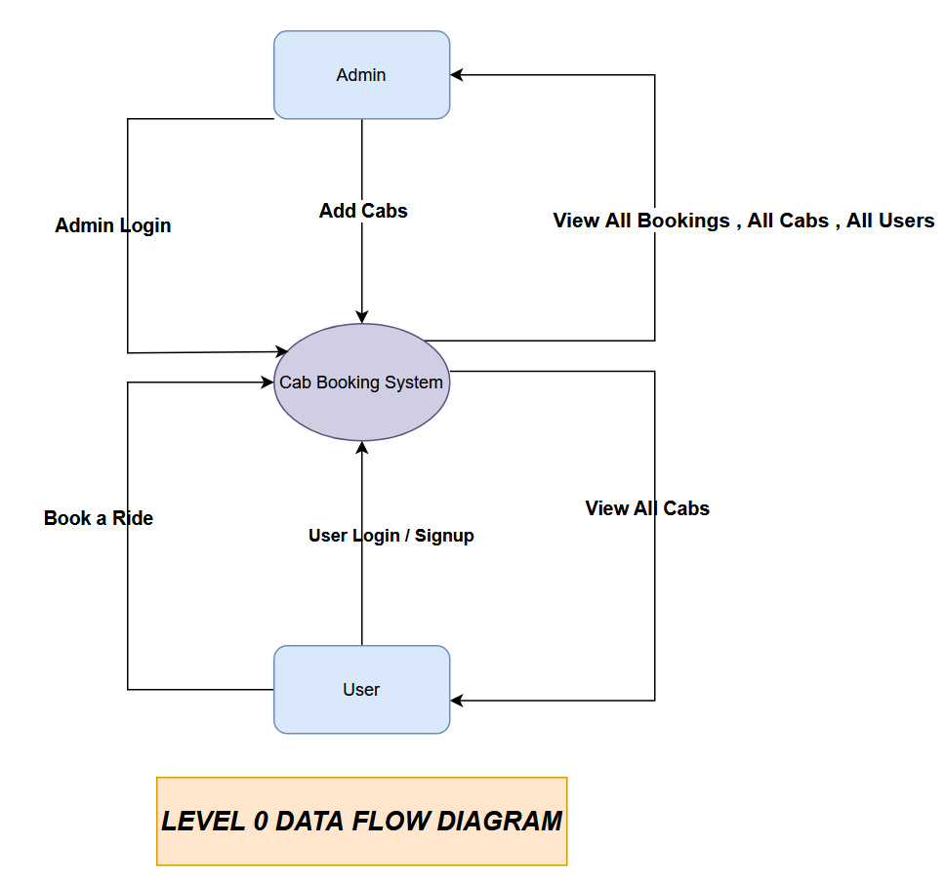

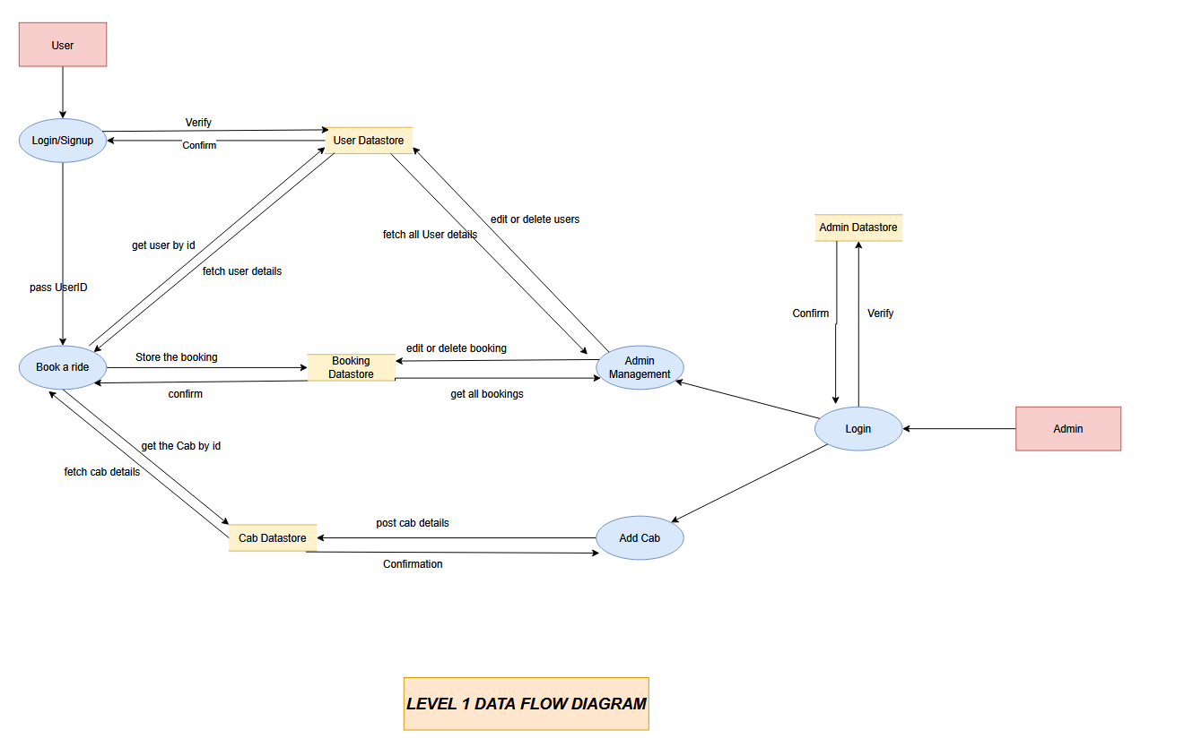

**User Stories :**

| **Type** | **Functional Requirement (Epic)** | **User Story Number** | **User Story / Task** | **Acceptance Criteria** | **Priority** | **Release** |
| --- | --- | --- | --- | --- | --- | --- |
| Customer (Mobile user) | Registration | USN-1 | As a user, I can register for the application by entering my email, password, and confirming my password. | I can access my account/dashboard | High | Sprint-1 |
| Customer (Mobile user) | Registration | USN-2 | As a user, I will receive a confirmation email once I have registered for the application. | I can receive confirmation email & click confirm | High | Sprint-1 |
| Customer (Mobile user) | Registration | USN-3 | As a user, I can register for the application through Facebook. | I can register & access the dashboard with Facebook Login | Low | Sprint-2 |
| Customer (Mobile user) | Registration | USN-4 | As a user, I can register for the application through Gmail. | I can register & access the dashboard with Gmail Login | Medium | Sprint-1 |
| Customer (Mobile user) | Login | USN-5 | As a user, I can log into the application by entering email & password. | I can successfully log in and access the application | High | Sprint-1 |
| Customer (Mobile user) | Location services | USN-4 | As a user, I can set my pickup location using GPS or manual entry. | I can set and save my pickup location successfully | High | Sprint-2 |
| Customer (Mobile user) | Ride Booking | USN-5 | As a user, I can search for available cabs near my location. | I can view available cabs in my vicinity | High | Sprint-2 |
| Customer (Mobile user) | Ride Tracking | USN-6 | As a user, I can track my assigned cab in real-time. | I can see real-time updates of my cab's location | Medium | Sprint-3 |
| Customer (Mobile user) | Payment Integration | USN-7 | As a user, I can pay for my ride using various payment methods. | I can complete payments using different payment options | High | Sprint-3 |
| Customer (Mobile user) | User Rating | USN-8 | As a user, I can rate my ride experience after completion. | I can submit a rating and review for my ride | Low | Sprint-4 |
| Customer (Mobile user) | Ride History | USN-9 | As a user, I can view my past ride history and details. | I can see a list of past rides with details | Medium | Sprint-4 |
| Customer (Web user) | Registration | USW-1 | As a user, I can register for the application by entering my email, password, and confirming my password. | I can access my account/dashboard | High | Sprint-1 |
| Customer (Web user) | Registration | USW-2 | As a user, I will receive a confirmation email once I have registered for the application. | I can receive confirmation email & click confirm | High | Sprint-1 |
| Customer (Web user) | Registration | USW-3 | As a user, I can register for the application through Facebook. | I can register & access the dashboard with Facebook Login | Low | Sprint-2 |
| Customer (Web user) | Registration | USW-4 | As a user, I can register for the application through Gmail. | I can register & access the dashboard with Gmail Login | Medium | Sprint-1 |
| Customer (Web user) | Login | USW-5 | As a user, I can log into the application by entering email & password. | I can successfully log in and access the application | High | Sprint-1 |
| Customer (Web user) | Location services | USW-6 | As a user, I can set my pickup location using GPS or manual entry. | I can set and save my pickup location successfully | High | Sprint-2 |
| Customer (Web user) | Ride Booking | USW-7 | As a user, I can search for available cabs near my location. | I can view available cabs in my vicinity | High | Sprint-2 |
| Customer (Web user) | Ride Tracking | USW-8 | As a user, I can track my assigned cab in real-time. | I can see real-time updates of my cab's location | Medium | Sprint-3 |
| Customer (Web user) | Payment Integration | USW-9 | As a user, I can pay for my ride using various payment methods. | I can complete payments using different payment options | High | Sprint-3 |
| Customer (Web user) | User Rating | USW-10 | As a user, I can rate my ride experience after completion. | I can submit a rating and review for my ride | Low | Sprint-4 |
| Customer (Web user) | Ride History | USW-11 | As a user, I can view my past ride history and details. | I can see a list of past rides with details | Medium | Sprint-4 |
| Customer Care Executive | Manage Customer Queries | USCC-1 | As a customer care executive, I can view and respond to customer queries. | I can see and respond to customer inquiries | High | Sprint-1 |
| Customer Care Executive | Manage Ride Issues | USCC-2 | As a customer care executive, I can handle issues related to rides reported by users. | I can track and resolve ride-related issues | High | Sprint-2 |
| Customer Care Executive | Access User Information | USCC-3 | As a customer care executive, I can view user information for support purposes. | I can access and review user information | Medium | Sprint-3 |
| Customer Care Executive | View Ride History | USCC-4 | As a customer care executive, I can view user ride history to assist with queries. | I can see details of users’ past rides | Medium | Sprint-4 |
| Administrator | Manage Users | USA-1 | As an administrator, I can add, edit, and delete user accounts. | I can manage user accounts effectively | High | Sprint-1 |
| Administrator | Monitor Application Performance | USA-2 | As an administrator, I can monitor application performance and usage statistics. | I can access performance metrics and reports | High | Sprint-2 |
| Administrator | Manage Content | USA-3 | As an administrator, I can update and manage content displayed in the application. | I can make changes to application content | Medium | Sprint-3 |
| Administrator | Configure Settings | USA-4 | As an administrator, I can configure application settings and preferences. | I can adjust application settings as needed | Medium | Sprint-4 |
| Administrator | Access System Logs | USA-5 | As an administrator, I can access system logs to troubleshoot issues. | I can view and analyze system logs | High | Sprint-4 |